Purpose
The purpose of this document is to provide best-practice guidance for the installation of grade control structures to ensure Melbourne Water achieves consistent, high-performing geomorphic and environmental outcomes.

Scope

Inclusions
This guideline applies where grade control structures, sometimes referred to as rock chutes, are to be installed along waterways within the Melbourne Water region, and covers the following industry-specific best practices:
- design drawing checks (structure crest, face, apron and abutment protection);
- materials specification checks (rock, filter layer);
- installation best practice (site set-out, excavation, installation, demobilisation).

Exclusions
This guideline does not cover the assessment of bed instabilities, comparison and selection of a preferred intervention strategy, provision of fish passage or the design of grade control structures.
Determining whether installation of a grade control structure is the appropriate management strategy for a particular waterway is the responsibility of the project initiator, who should consider a number of factors, including:
- the geomorphic processes (and drivers) operating within the waterway;
- the threats posed by these processes to waterway values and/or assets;
- the benefits and risks of alternative strategies, e.g. nature-based solutions;
- the likely outcomes under a ‘do nothing’ scenario.
Grade control structures are most successful when installed as part of a holistic management approach that includes fencing (to exclude access from livestock, pedestrians, etc.), revegetation and ongoing weed maintenance. These supplementary management activities are essential to the long-term success of grade control structures. This guideline should not be read in isolation, but applied with other relevant guidelines, in particular the Technical Guidelines for Waterway Management (DEECA 2024) and Melbourne Water’s Constructed Waterways Design Manual.

Design drawing checks
Bank stabilisation designs should be completed with consideration of Melbourne Water’s Constructed Waterways Design Manual. Based on the design, installation requirements are documented on design drawings.
It is the project manager’s responsibility to understand the design drawing and verify that the installation requirements are suitable and sensible for the site conditions. Where an adjustment or alternative technique is identified based on site conditions, the project manager should discuss the proposed changes with the designer.
Variations from the design drawing should not be implemented without the approval of the designer.
A grade control structure is a relatively short and steep section of the bed of a channel that has been armoured with rock (DEECA, 2024).
A grade control structure’s geometry consists of the following elements (see Figure 1):
- crest
- face
- apron
- abutment protection.
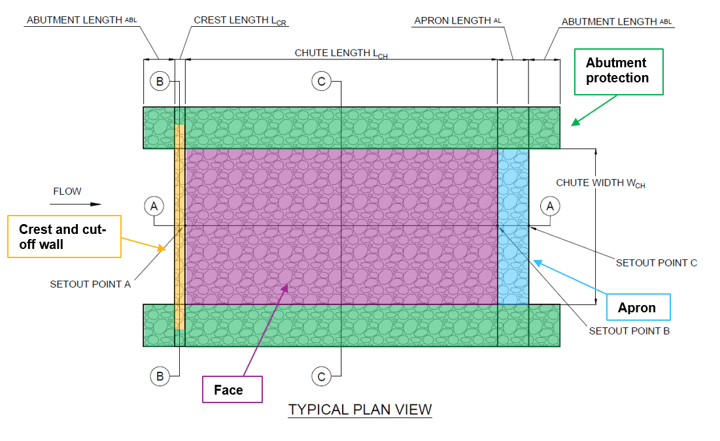
Figure 1: Typical plan view of grade control structure with geometry elements highlighted

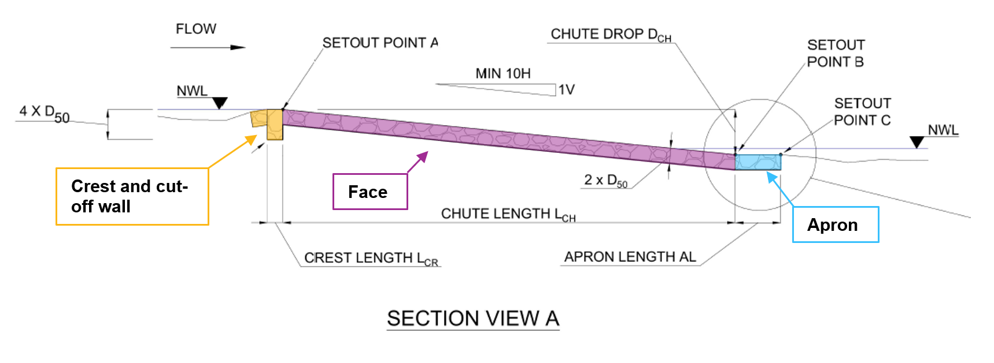
Figure 2: Typical long section view of a grade control structure with geometry elements highlighted
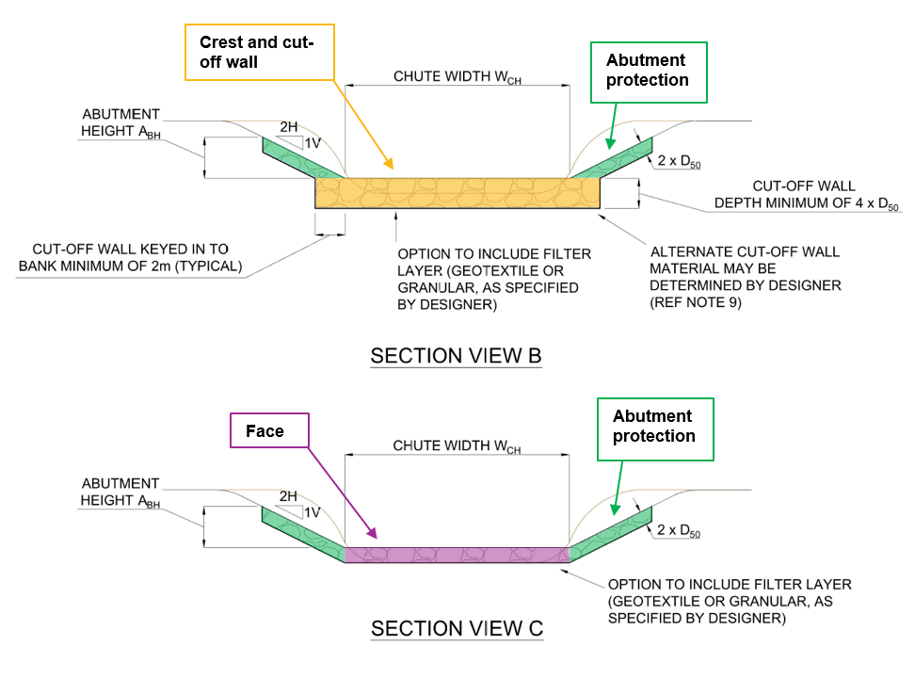
Figure 3: Typical cross section view of grade control structure with components highlighted (refer MW Grade Control Structures Standard Drawing for full detail).
The project manager should ensure that the location and height of the grade control structure has adequately considered the:
- planform of the channel - the grade control structure should be installed on a straight section of waterway with little to no bends;
- impact to adjacent values, e.g. will any established vegetation require removal to construct the structure?
- impact to upstream values and conditions, e.g. will the design height cause flooding problems? Will assets (natural, man-made) be at increased risk due to altered water levels?
- channel bed levels and bed stability - the crest should be at or slightly above local bed levels and end of the apron should be at or slightly below local bed levels.
The following sections provide background and advice to project managers on understanding and verifying key elements of the grade control structure design drawing.

Crest
The crest is the upstream extent of the grade control structure. The location and height of the crest will be determined by the designer and included in design drawings.

Crest width
The crest width is the distance from bank to bank and is determined by the designer.

Crest depth
The depth of the crest (see Figures 2 and 3) is determined by the designer, but is typically excavated to a depth of 4 x D50.

Crest length
The crest length is determined by the grade control structure designer and is typically 1m long in the direction of flow or greater.

Crest cut offs
Crest cut offs (see Figures 1 and 3) are the extensions of the crest into the bank on each side of the grade control structure meaning they are a continuation of the crest. Typically, crest cut offs extend 1-2m into the bank (or a minimum of 4xD50) on each side of the creek, beginning at a depth equal to the crest depth and shallowing to a depth of approximately 1m at their endpoint.

Face
The grade control structure face extends from the crest (upstream) to the apron (downstream) and its location and extent will be determined by the designer and included in the design drawings.

Face width
The width of the face is often equal to the width of the crest and is determined by the designer.

Face Slope
The slope of the face is determined by the designer but should not be steeper than 10H:1V.
The project manager should ensure that the slope is consistent for the length of the slope face, i.e. there should be no localised steep points or shallow points along the face.

Face Thickness
The minimum thickness of the face should be 2xD50 .

Apron
The grade control structure apron extends from the downstream end of the face and its location and extent will be determined by the designer and included in design drawings.

Apron Width
The width of the apron is often equal to the width of the face and is determined by the designer.

Apron Length
Typically, the apron is a minimum 3m long with a flat grade that sits at the same level as the streambed immediately downstream. In some instances (e.g. where there is insufficient tailwater), the designer may require an apron rise.
The project manager should ensure that the surface of the grade controls structure at the downstream end of the apron is at (or slightly below) the stream bed level.

Apron Thickness
The minimum thickness of the apron is the same as the face and should be 2xD50.

Abutment protection

Along the length
The banks on either side of the grade control structure should be protected with rock to a thickness of 2xD50.
The height of abutment protection along the grade control structure will be determined by the designer.

Upstream
To prevent failure by outflanking of the crest, the abutment protection should extend upstream of the crest for a minimum of 3m along both banks.

Downstream
The abutment protection should also extend downstream of the apron for a minimum of 3m along both banks.
The project manager should ensure that the length of protection downstream of the apron adequately considers flows exiting the grade control structure e.g. if there is a bend immediately downstream of the structure, abutment protection may require extension greater than 3m along the outside bank.
The length of protection upstream of the crest should also consider any bend immediately upstream and the associated risk of outflanking the crest.

Materials specification checks

Rock

Quality
Rock should be clean, hard, angular, durable, free from cracks and should not be adversely affected by repeated wetting and drying.
The project manager should check that all rock to be used for grade control structure meets the above requirements, together with those listed in Table 1.
Table 1: Rock durability requirements
Test procedure | Requirements
Relative density (density of dry solid rock relative to water) | >2.1 (e.g. granites, basalts, sandstone)
Crushing strength | 25 MPa
Abrasion (Abrasion Grading A) Los Angeles Abrasion test (AS 1141.23) | <40% loss of weight after 500 revs.

Size and gradation
Rock used for grade control structures should not be single sized, but should be a well-graded mixture such that all gaps between larger rocks are filled with rocks of a progressively small size. This will:
- ensure that no significant voids occur within the grade control structure that could promote flow underneath the structure;
- create an interlocking mass of rock where no individual rock can move by itself;
- avoid high drag forces along the face of the structure as no individual rocks will significantly protrude into the flow.
If constructed properly the rock mix should ensure there are no excessive voids. This will avoid the need to pulling smaller rocks out of the mix to fill voids.
The classifications and gradations for rock are listed in Table 2. The maximum rock size shall not be larger than the thickness of the grade control structure layer (i.e. 2 x D50).
Table 2: Rock size specification
Equivalent sieve size | Percentage (by weight) finer
2 x D50 | 100%
D50 | 50%
0.3 x D50 | 10%
Overburden, shale or organic matter should not form part of the rock mix.
The project manager should ensure that the D50 rock size (described in the design drawing) with the required size specification (detailed in Table 2) can be sourced from the nominated quarry.
The site supervisor should ensure that each load of rock delivered to site meets the rock size specification.

Shape
Rock should be angular in shape. Rounded rock should not be used.
The breadth or thickness of a single rock should not be less than one third its length i.e. thin, slab-type rocks shall not be used.

Filter layer
A filter layer between the grade control structure and the streambed is likely to be required where the streambed material is non-cohesive (such as sand). Melbourne Water’s preferred approach to a filter layer is the installation of an embedment layer of graded quarry rock. In exceptional circumstances Geotextile may be installed as a filter layer (as detailed in the Installation best practice section). The type and specification of the filter layer should be specified by the designer based on site conditions.
The project manager should check whether the conditions described above occur at the site and, if so, whether the installation of a filter layer may be required.
Where conditions require provision of a filter layer between the grade control structure and the streambed, one of the following types can be considered:
- granular filter layer of smaller gravels; or
- geotextile.
Advantages and disadvantages of these filter layers are presented in Table 3.
Table 3: Comparison of filter materials for grade control structures
Filter material | Advantages | Disadvantages
Granular filter layer | - Self-healing in some circumstances  - Generally, very durable | - Careful control needed to achieve specified grading and thickness.
Geotextile | - Cost  - In-plane tensile strength  - Limited thickness | - Easy to damage, difficult to repair  - Introduction of synthetic fibres to a natural environment.  - Careful installation needed to accommodate settlement of uneven foundation and associated undermining.

Installation best practice

Site set-out
The project manager should check and approve the following site set-out elements prior to any excavations:
- crest location (typically with marker pegs, star pickets or marker spray);
- crest height (a survey peg driven into the ground to the design height at a distance close enough for reference but away from the construction footprint);
- apron location (typically with marker pegs, star pickets or marker spray indicating the start/upstream and end/downstream of the apron);
- apron height (a survey peg driven into the ground to the design height at a distance close enough for reference but away from the construction footprint).

Excavation
Industry preference is to utilise excavators for grade control construction. Where rock cannot be delivered close to the construction site, a wheeled loader can be useful to transport rock from stockpiles to site.
Site excavations should be undertaken in dry conditions. Where this is unavoidable, water can be diverted around the site via partial width construction (e.g. via pipes) or by-passed using one or more pumps. These options typically require the construction of coffer dams both upstream and downstream of the site.
The project manager should ensure that design drawings adequately describe the dimensions for excavations.

Installation
Once the site has been excavated to the design requirements installation of the grade control structure can begin.
Under dry conditions, Melbourne Water’s preference is to install the grade control structure from downstream to upstream. Construction should begin with the apron and work up the rock face towards the crest. Where storm risks are high (or where dewatering activities are underway), the crest should be built first then work downstream towards the apron.
Rock is placed by excavator, with care given to avoiding excessive segregation of size fractions in the rock mix as each bucket load is placed.
Installation guidelines for specific elements of a grade control structure are provided in the following sections.

Crest
To minimise the risks of outflanking or undercutting where there is the risk of wash-out of underlying material (e.g. sand), it is important that the crest provides sufficient hydraulic obstruction such that upstream flows entering the structure flow over the top of the crest and not through or around the rock work. This is best achieved by lining the excavated trench (and cut-offs) at the crest with geotextile.
The geotextile should cover the full depth and width of the trench (including cut-offs) and rise to the design crest height. Rock can then be placed carefully behind the geotextile ensuring that no holes or tears occur. Once rock has been placed and compacted to the design crest height, the geotextile can be cut. The technical specifications of the geotextile should be set by the designer.
As geotextile is difficult to place and fold in flowing or wet conditions, it is standard practice to dewater the crest trench prior to construction.

Face and Apron
Where possible, construction of the face and apron should be completed by placing rock from the bank with an excavator. However, in wide streams (or where bank access is limited) construction may need to be completed in-stream. In these circumstances, it is industry practice for the excavator to sit and work from rock that has already been placed into the structure.
Rock should never be dumped over the edge from a truck as this will separate the rock mix into various size fractions, resulting in voids between rocks.
In specific circumstances (e.g. sand bed streams), the structure design may include installation of a filter layer beneath the rock of the face and apron. This can be either a geotextile or a granular filter layer of smaller gravels as specified by the designer. As with the crest construction, care should be taken to ensure that rock does not tear or significantly disturb the filter layer.

Demobilisation
After the grade control structure has been installed, the project manager should check to ensure that:
- the finished surface of the structure forms an even, well-interlocked bed with a naturally rough surface. The surface should not appear as a flat, paved finish, but equally there should not be any isolated protruding rocks. The intent is a hydraulically consistent bed that dissipates energy evenly across the width of the structure;
- any top soil from site preparation has been re-spread over disturbed ground;
- imported top soil material should comply with Melbourne Water’s specifications for soils and landscaping of constructed Melbourne Water Assets;
- planning is underway for the revegetation.
For grade control structures constructed in flowing waterways, the project manager should visually check the following flow conditions across and down the face:
- even distribution of flows across the crest and down the face (i.e. no concentrated flow paths);
- consistent slope down the face - look for flow accelerations (potential steep sections) and/or pooling (potential flat sections).
Any issues in flow distribution and/or slope should be rectified while machinery is still on site.

References
Document title
Constructed Waterway Design Manual
Specifications for soils and landscaping of constructed Melbourne Water assets
Technical Guidelines for Waterway Management (DEECA, 2024)

Document History
Date | Reviewed/  Actioned By | Version | Action
August 2026 | Asset Manager, Service Enablement | 1 | First published version.

A D₅₀ rock size is defined as being the size of rock in a rock mix where 50% of all rock in the mix (by weight) is larger than it and 50% (by weight) is smaller than it.

